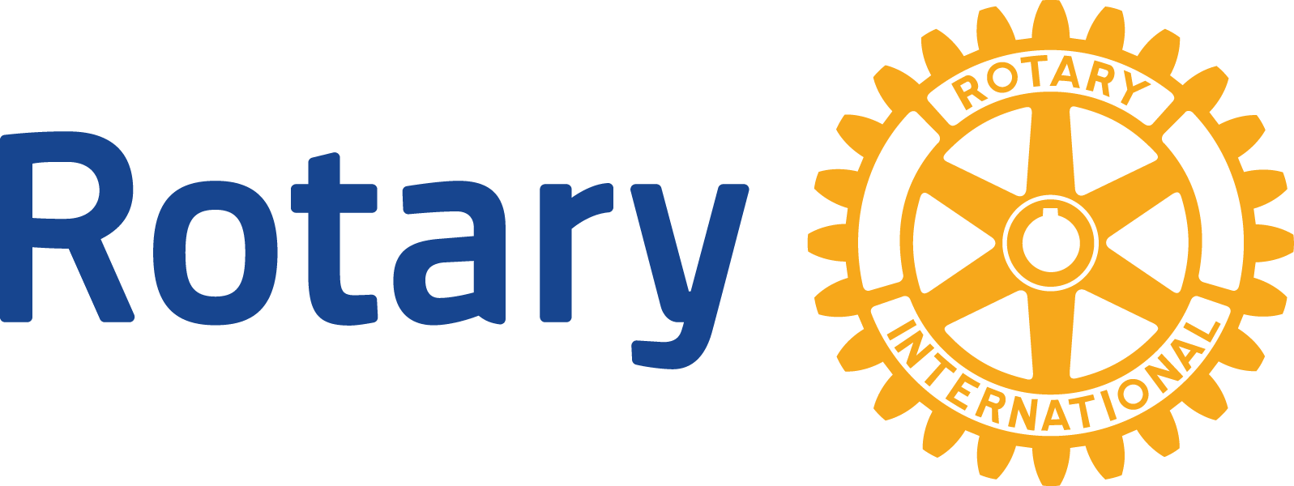
ENGLISH (EN)

Rotary Alumni - Frequently asked questions

Who are Rotary alumni?
Rotary alumni are individuals who have experienced Rotary through various programs, including:
- Interact
- Rotaract
- Rotary Youth Exchange
- New Generations Service Exchange
- Rotary Youth Leadership Awards (RYLA)
- Rotary Peace Fellowships
- Rotary Scholarships (global grants and district grants)
- Vocational training teams (members and leaders)
- Ambassadorial Scholarships
- Grants for University Teachers
- Group Study Exchange (members and leaders)
- Rotary Volunteers

Why did the definition change?
During the 2013-14 Rotary year, both the RI Board of Directors and The Rotary Foundation Trustees recognized the value of keeping everyone who has experienced the benefit of Rotary programs connected to the organization.

Why is it important to keep alumni connected to Rotary?
Past program participants have experienced Rotary firsthand:
- They are part of the Rotary family, having benefited from its programs.
- They can contribute to service projects.
- They are great resources for promoting Rotary.
- They are potential donors.
- They are potential Rotarians.

How many Rotary alumni are there?
Since Rotary International has only kept partial records over the years, no one knows exactly how many people have participated in Rotary programs going back to 1947. A conservative estimate is that there are more than 500,000 individuals who have had a positive experience in one of its programs.

What can districts and clubs do to involve Rotary alumni in their activities?
- Build strong relationships with current program participants.
- Develop an action plan for keeping alumni involved in Rotary activities and transitioning them into Rotarians.
- Promote alumni so that other Rotarians understand their importance.
- Ask alumni to join - and continue asking even if an initial invitation is declined.
- Help alumni find clubs that meet their needs.
- Use alumni to start new clubs.
- Maintain contact with younger alumni until they are qualified for membership.
- Involve alumni in other programs.
- Involve alumni in club and district activities.

How can Rotarians get information about the alumni in their district?
Rotary International is currently upgrading its technology to have better data and reporting about alumni. For the time being, reports are available by request only to alumni@rotary.org. Starting in early 2015, alumni reports should become available through My Rotary.

How can alumni update their information with Rotary?
For the time being, alumni should complete the Rotary Program Participation Survey to let Rotary know their latest contact information by completing our Rotary Program Participation Survey. Starting in early 2015, alumni will be able to update their contact information through My Rotary.

How can Rotarians update alumni information they know to be incorrect?
Rotarians can ask alumni to complete the Rotary Program Participation Survey or email corrections to alumni@rotary.org.

What is a Rotary alumni association?
A Rotary alumni association is an active organization of former Rotary program participants which seeks to maintain connections between these outstanding individuals and Rotary.

